NOOR NADEEM

**BEAUTY AND THE BEAST**

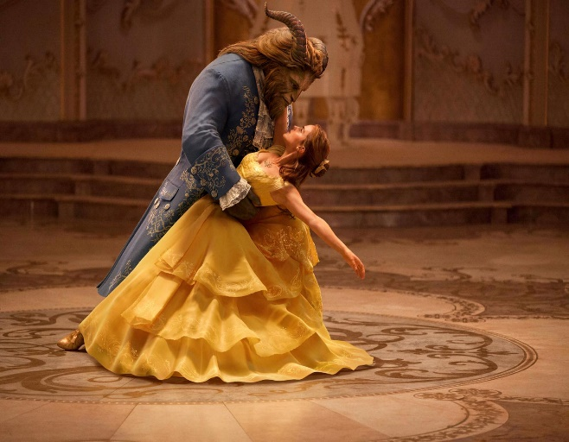ONCE UPON A TIME, THERE WAS A GIRL NAME BEAUTY. SHE LIVED WITH HER FATHER AND ******HER SISTER IN A SMALL.

***INTRODUCTION OF BEAUTY***

* Beauty was a Beautiful Gir
* She Was Also Hard Working.
* She Always Helped Her Father ON The Farm.

***STORY OF BEAUTY***

* One Day, Her Father Set Out for The City. He Saw an Old Castle and Went In. No One Was in But There Was Food on A Table. Then He Walked Around the Castle. He Picked a Rose from Garden for Beauty Suddenly an Angry Beast appeared. He Wanted to Kill Beauty ‘S Father Unless Beauty Was Brought to Him.
* Beauty’ S Father Told Her Daughter What Had Happened. Beauty’ S Sisters Ordered Her to See the Beast.
* Beauty Went to See the Beast and Had to Stay at The Castle. She Felt Scared, Lonely and Sad. She Tired to Run Away but Was Stopped by The Beast. The Beast Treated Beauty Well. Soon. Beauty Began to Like the Beast.
* One Day, Through the Beast’ S Magic Mirror. Beauty Saw That Her Father Was Sick. The Beast Allowed Her to Go Home. Her Father Was Happy to See Her.
* One Night, Beauty Had a Dream. A Fairy Told Her That the Beast Was Sick.
* Beauty Hurried Back and Saw the Beast Dying. She Began to Cry. Tears Fell onto The Beast.
* Suddenly, The Beast Changed into Handsome Prince.
* Beauty And the Beast Got Married and Lived Happily Ever After.

|  |  |
| --- | --- |
| *BEAUTY* | *BEAST* |
| *Beauty Was a Beautiful Girl.* | *Beast Is Originally a Handsome Prince.* |
| *She Was Also Hard Working.* | *He Is a Selfish Boy.* |

*BEAUTY*

AND THE

*BEAUTY*

***BEAST***